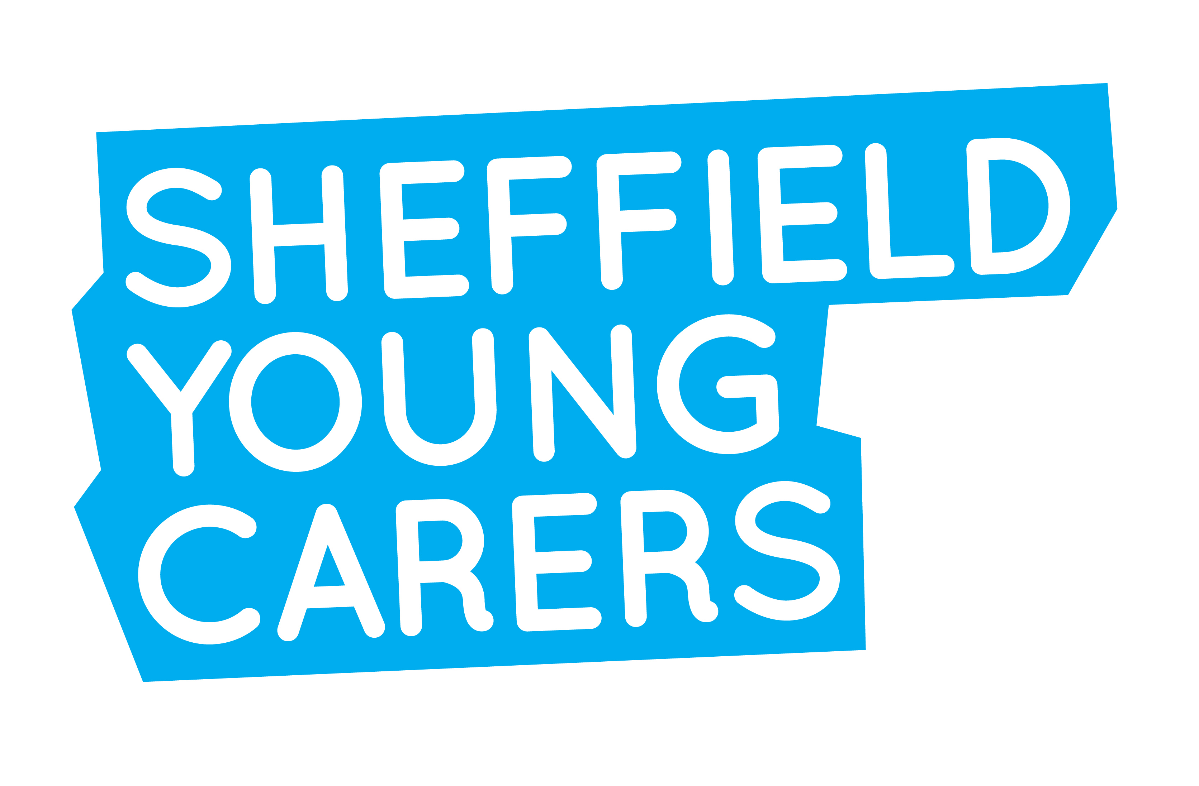

Digital Development Officer – 17.5 hours per week

Salary: £12,500 pro rata (£25,000 FTE)
Hours: 17.5 hours per week

We have a vacancy for a highly motivated Digital Development Officer to help extend our reach and engage new audiences including service-users, strategic partners and supporters. Passionate about all things digital, you will possess the technical and creative skills to maximise the potential of SYC’s digital communications. The work will include implementing SYC’s digital communications strategy; maintaining and developing SYC’s website, quarterly e-newsletter and social media platforms; and developing new forms of online support for young people, families and professionals.

Sheffield Young Carers (SYC) is a service for young people aged between 8 and 25 who:
- are taking on a substantial caring role for a member or members of their family who have a disability, a long term physical or mental illness
- and/or are affected by substance misuse in their family.
We provide individual and group support for young people and support for families. We also work with local and national organisations to improve support for young carers and young people affected by familial substance misuse.
This is an exciting opportunity to build your skills and experience in a growing, vibrant organisation where your ideas and contributions will be highly valued. You will have experience of:
- developing and implementing a digital communications strategy
- using a variety of marketing tools, content management systems and social media platforms, e.g. Squarespace, Mailchimp, Twitter, Facebook, Instagram
- designing, creating and managing social media campaigns
- creating, reviewing and editing content, including written, audio and video content.

You will need to be able to work well in a team as well as being able to work on your own initiative.
We are committed to safeguarding and promoting the welfare of children. Successful applicants will be required to complete an enhanced Disclosure and Barring Service (DBS) check prior to commencement of the post.

SYC is an Equal Opportunities Employer and welcomes applications from all sections of the community. We offer 5% pension contributions and a staff health and wellbeing fund.

For an application pack and further information please visit www.sheffieldyoungcarers.org.uk/news. If you experience any difficulties accessing the information, email katie@sheffieldyoungcarers.org.uk. If you do not receive a reply within two days, please ring Katie Borland on 0114 258 4595.

Closing date for receipt of applications: 4pm on Thursday 3rd October 2019
Interviews scheduled for: Wednesday 16th October 2019

